**Initial exploration of the data:**

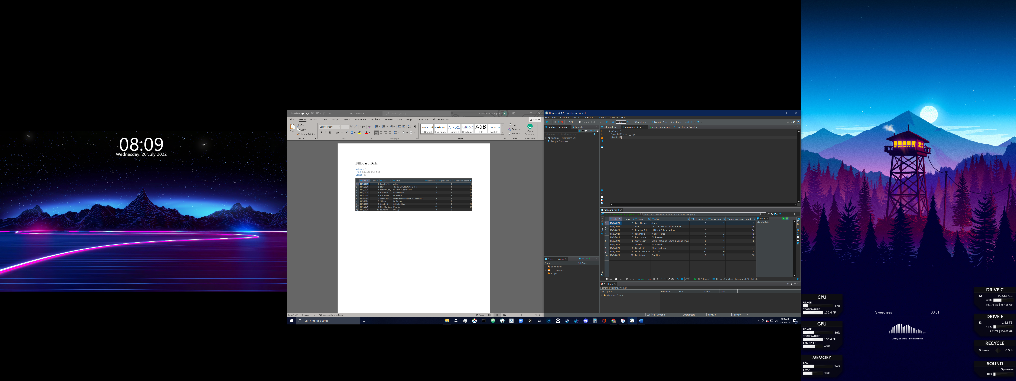

**How many unique artists with or without features in the data set:**

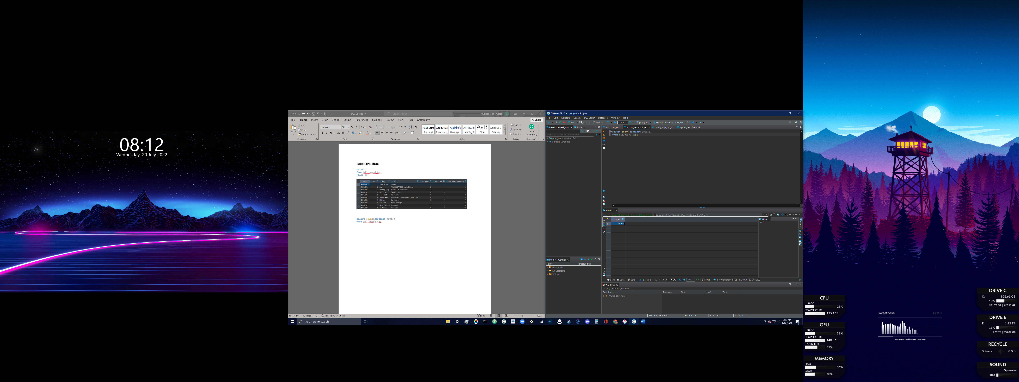

**Observing the ‘Date’ range of the data:**

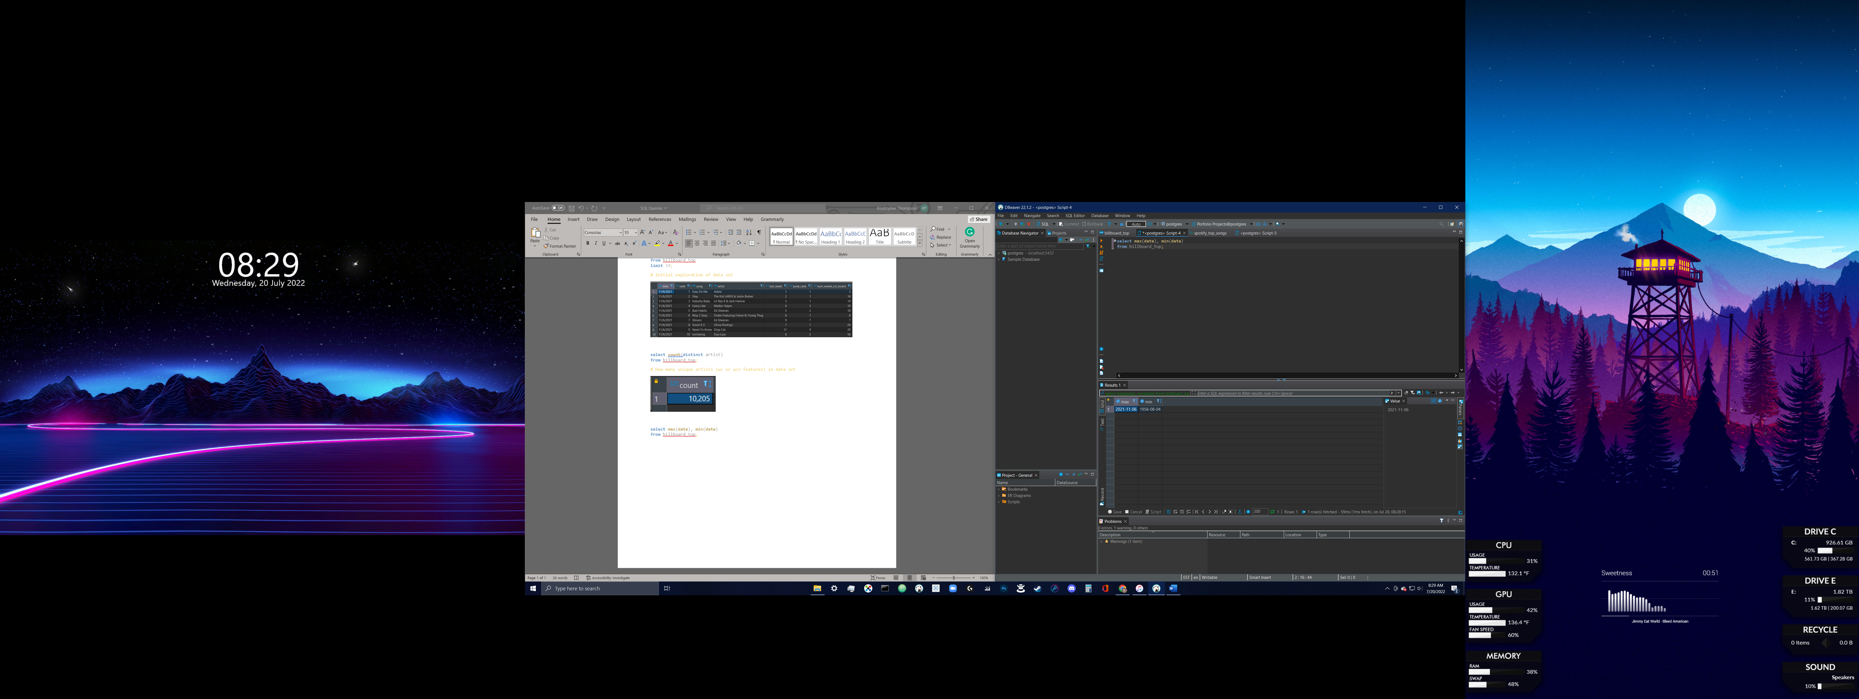

**Artists with the most songs on Billboard Top 100:**

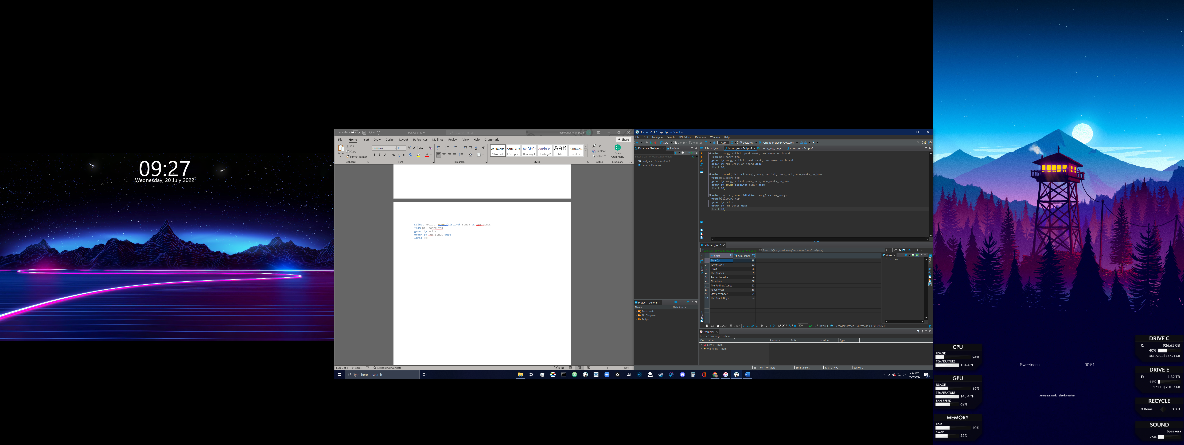

**Top 10 songs with the most weeks on the Billboard Top 100:**

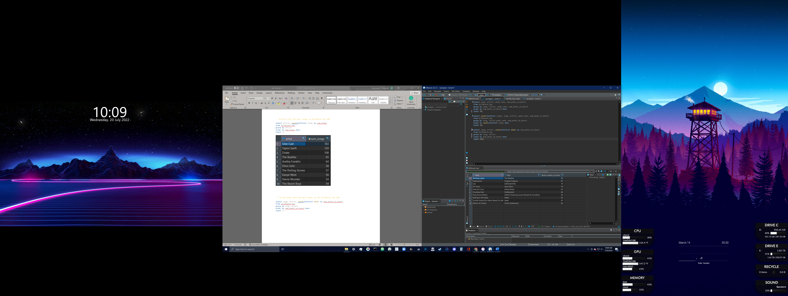

**List of songs within the top 15 spots with the most weeks on the Billboard Top 100; Years with less songs shown means there was a much larger gap between the top song(s) and the less popular songs for that year:**

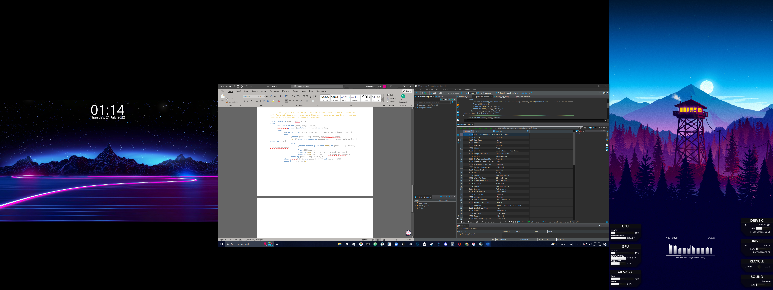

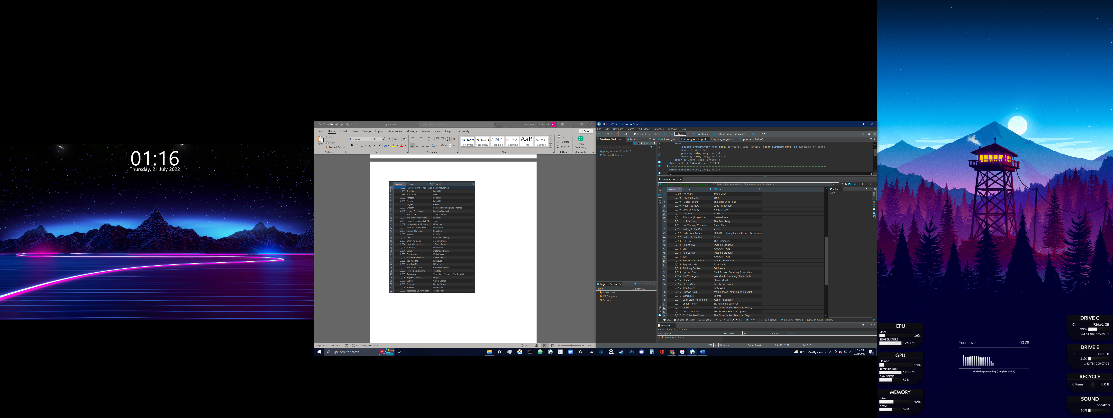

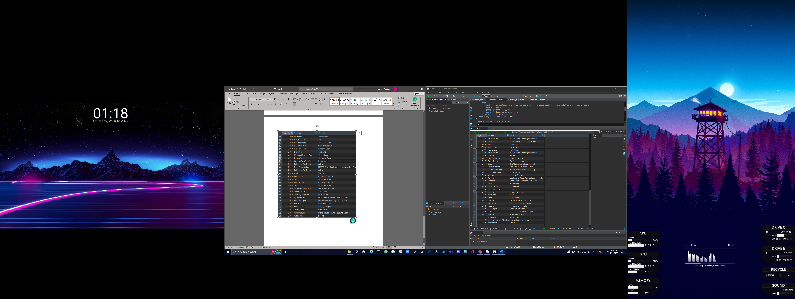

**Joins:**

**List of songs on spotify that reached the top of the billboards for at least 1 week; 186 total rows displayed:**

**Top 15 songs:**

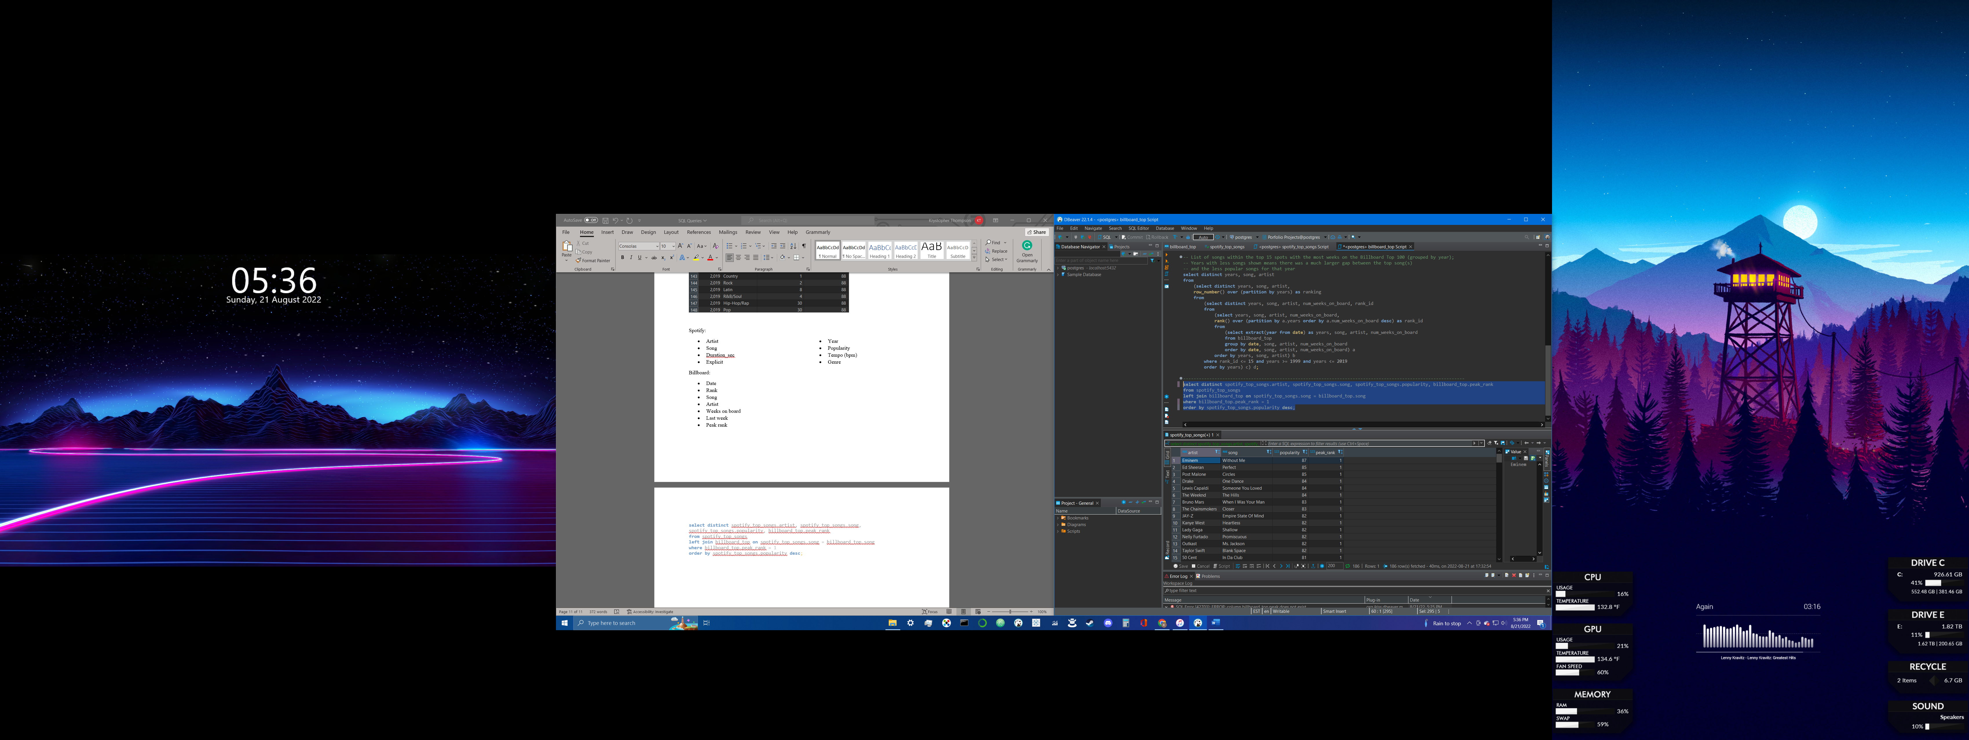

**Bottom 15 songs:**

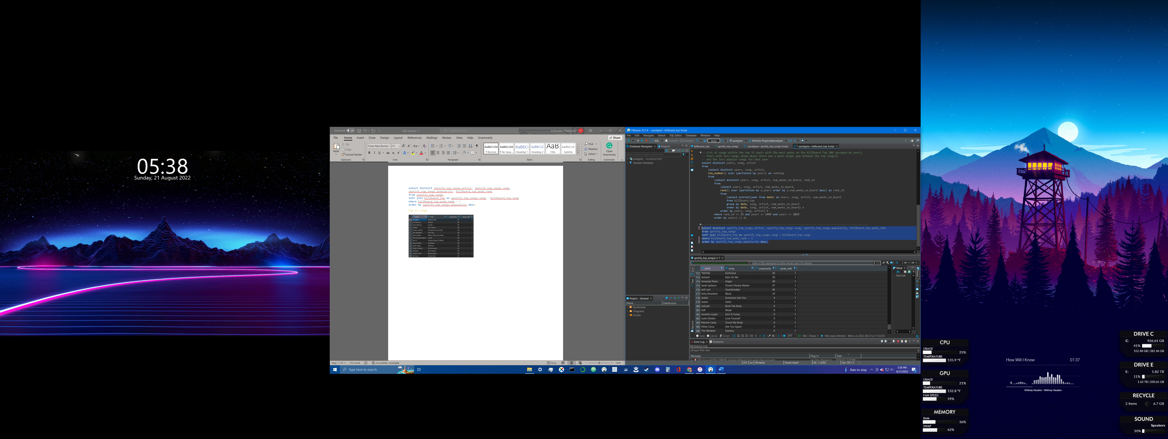

**According to spotify, the majority of songs that last the longest on the billboard charts tend to not be explicit:**

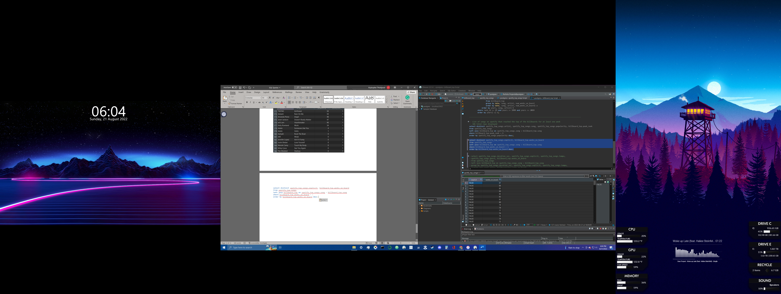

**While it looks like songs with lower BPM tended to be ranked lower on the charts compared to higher BPM songs, it’s a bit of a toss up on peak rank once a song reaches 114+ BPM:**

